Student ID: s4664741

Student Name: Sunil Chandra Paudel

Lab Activity: 3.3

* Description : Implement and test the Rational Number Program (slides 9 and 10). Then, implement the Operation __add__, __sub__, __mul__, __truediv__ for the Rational Operators (based on examples in slides 11 to 13)

Python Code (or Screen Capture)

# rational.py file

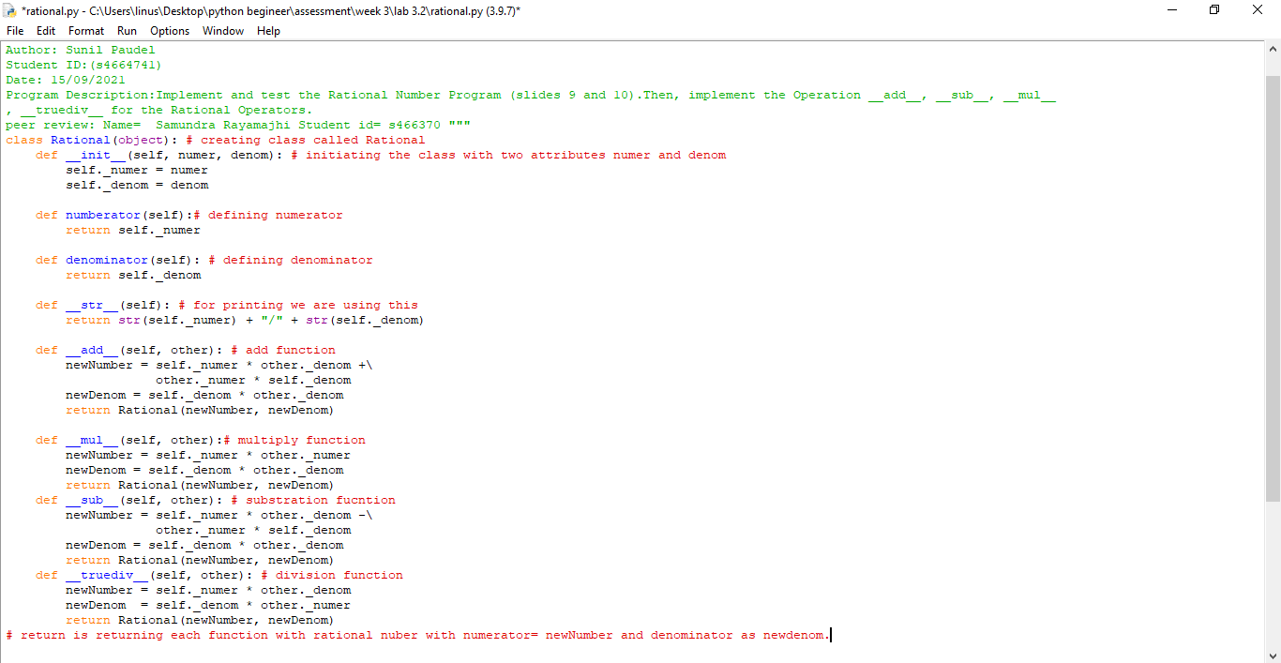

#rationaloperation

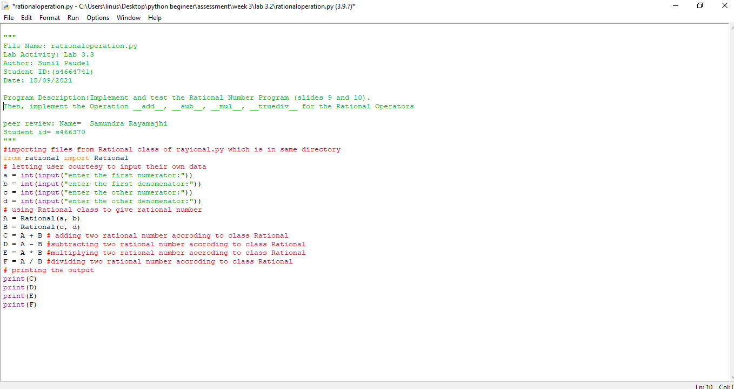

Test run (minimum 3 attempts)

My peer:

Student Name: Name= Samundra Rayamajhi

Student id= s466370

Feed back received:

Imported rational class from different file rational in same directory and use it to calculate the addition, subtraction, multiplication and division while letting user courtesy to input the numerator and denominator

Feeback given:

Have let the user courtesy to input the numerator and denominator and provide the result of addition, subtraction, multiplication and division of rational data